
Bachelor of Computer Applications
Semester – V
Business Analytics
Experiment No.: 3

Title: Retail Sales & Profit Performance Dashboard

Submitted By
Name: Dipin Roka
Reg. No.:2411021240007
Date:22/08/2026
Githublink
Submitted To:
Faculty Name: Mr. Aman Kumar Sharma

Department of Computer Application
Alliance University
Chandapura - Anekal Main Road, Anekal Bengaluru – 562106

Experiment No.: 3

A retail company relies on manually prepared reports to monitor business performance. Develop a Power BI dashboard showing sales, revenue, profit and product performance.

Problem Statement

A retail company relies on manually prepared reports to monitor business performance. DevelopPower BI dashboard showing sales, revenue, profit, and product performance.

Step 1: Data Collection
- Obtained Sales Data from Excel files (AdventureWorks_Sales_Data_2020.xlsx, 2021.xlsx, 2022.xlsx).
- Obtained Customer Data from CSV files (AdventureWorks_Customer_Lookup.csv).
- Obtained Product Data from another source, i.e., a MySQL database table (Product master table) and supporting CSV lookup files (Product, Product Category, Product Subcategory).
Step 2: Data Import
- Opened Power BI Desktop.
- Imported all datasets using the Get Data option (Get Data → Excel Workbook, Get Data → Text/CSV).
- Connected to the MySQL database using Get Data → Database → MySQL Database, and provided the server name and database name to import the Product table directly from MySQL.
- Loaded Excel, CSV, and MySQL data into Power BI Desktop.
Step 3: Data Cleaning and Transformation
- Removed duplicate records from the Customer and Product tables using Power Query's Remove Duplicates option.
- Handled missing values by replacing blanks/nulls using Replace Values and Fill Down options in Power Query.
- Renamed columns appropriately (e.g., Customer Key to Customer ID, ProductName to Product) for better readability.
- Converted data types where necessary — Date columns to Date type, Key columns to Whole Number, and Price/Cost columns to Fixed Decimal Number.
Step 4: Data Modeling
- Created relationships between the Sales (fact table), Customer, and Product (dimension tables) using common key columns such as Customer Key and Product Key.
- Verified that all relationships were one-to-many, with the lookup tables (Customer,
Product) on the “one” side and the Sales table on the “many” side.
- Used the Model view in Power BI Desktop to visually confirm the relationships and cardinality.
Step 5: Dashboard Development
- Created KPI cards for Total Sales, Total Orders, and Total Customers.
- Developed charts for Sales by Category and Sales by Region.
- Added slicers for Month, Category, and Region to enable interactive filtering.
- Designed an interactive business dashboard combining KPI cards, charts, and slicers on a single report page.

Output
The final Power BI dashboard provides the following outputs:
- Total Sales Performance
- Customer Analysis
- Product-wise Sales Analysis
- Monthly Sales Trends
- Interactive Filters and Slicers
The dashboard enables management to monitor business performance and make data-driven decisions effectively.

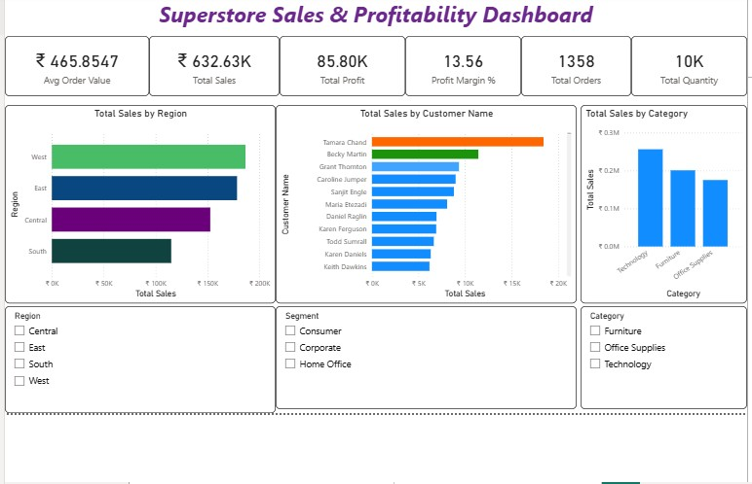

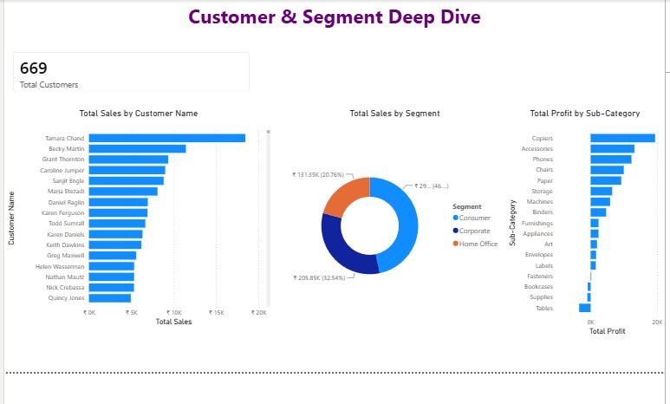
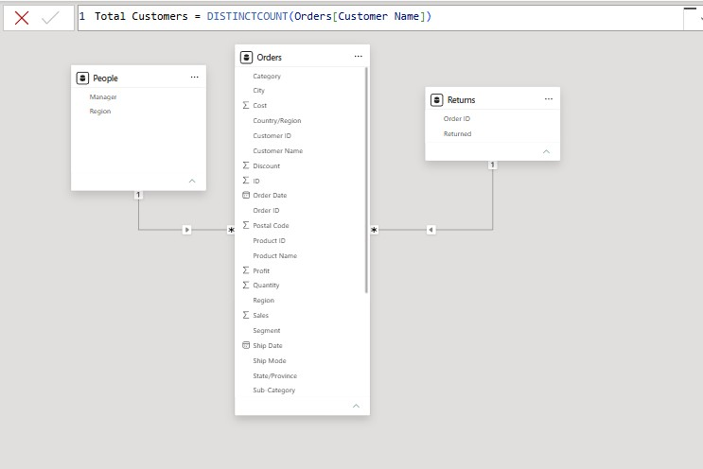

Conclusion
This project successfully integrated data from multiple sources — Excel, CSV, and MySQL — into Power BI and transformed it into meaningful business insights. Data cleaning, transformation, and modelling techniques were applied to ensure accurate reporting. The developed dashboard provides a centralized view of business performance and supports better decision-making.

Learning Outcomes
Through this project, I learned:
- How to import data from Excel, CSV files, and a MySQL database into Power BI.
- Data cleaning and transformation using Power Query.
- Creating relationships between multiple tables.
- Developing DAX measures and calculated columns.
- Designing interactive dashboards and reports.
- Generating business insights from raw data.

